Investigate the Law of Sines and Law of Cosines

You may use these websites or Google if necessary. You may also come in at lunch or after school for help.

<https://www.mathsisfun.com/algebra/trig-sine-law.html>

<https://www.mathsisfun.com/algebra/trig-cosine-law.html>

<https://www.khanacademy.org/search?referer=%2F&page_search_query=law+of+sines>

<https://www.khanacademy.org/search?search_again=1&page_search_query=law+of+cosines>

Investigate Heron’s formula.

<https://www.khanacademy.org/math/geometry/basic-geometry/heron_formula_tutorial/v/heron-s-formula>

Complete the following IXL Assignment.

**Algebra 2**

Y.17 Law of Sines

Y.18 Law of Cosines

Y.19 Solve a triangle

**Precalculus**

M.13 Law of Sines

M.14 Law of Cosines

M.15 Solve a triangle

[M.17 Area of a triangle: Heron's formula](https://www.ixl.com/math/precalculus/area-of-a-triangle-herons-formula)

**Your score for each skill will be computed as follows:**

**90 or greater A; 80 – 89 B; 70-79 C; 50-69 D; 0-49 F.**

**Your final grade for the assignment will be the average of the 7 grades earned.**

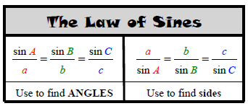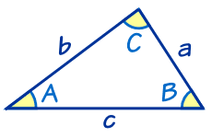

**Example 1**

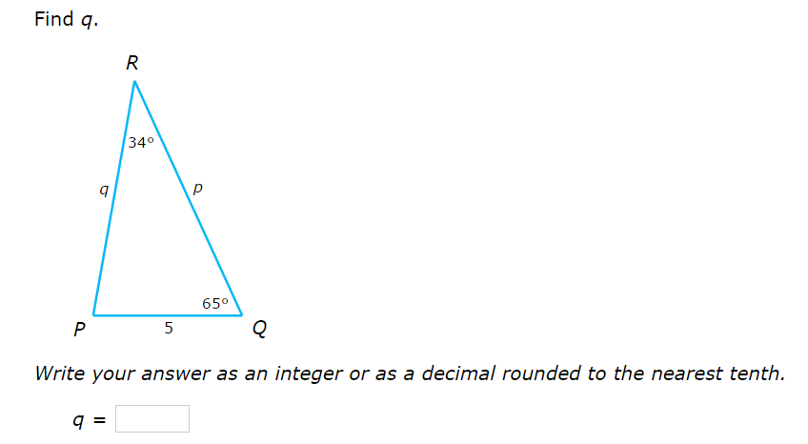

**Example 2**

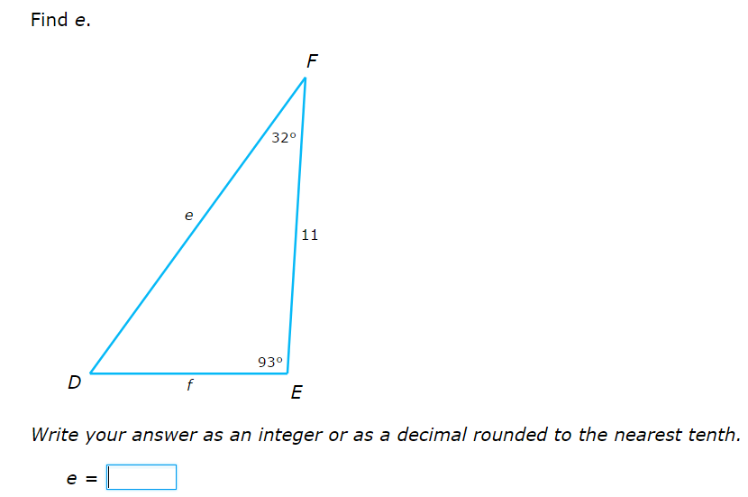

***Complete IXL Precalculus Skill M.13 Law of Sines***



**Law of Cosines**

 

**Example 1**

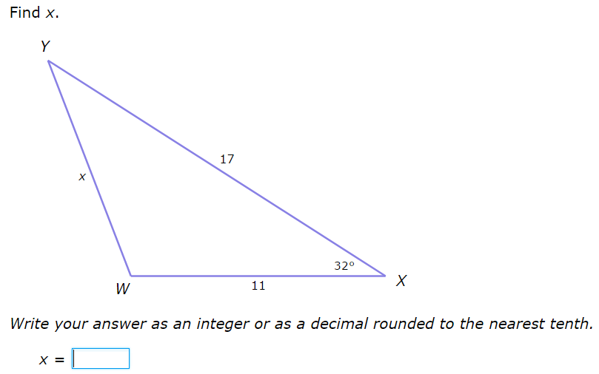

**Example 2**

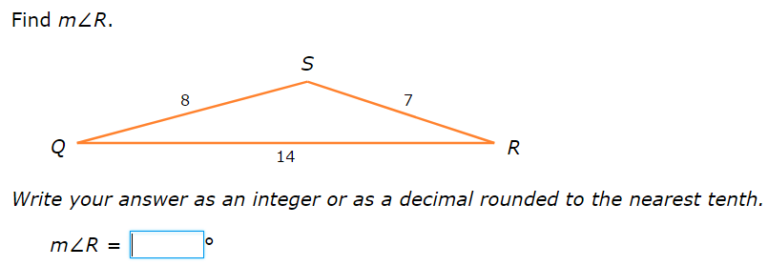

***Complete IXL Precalculus Skill M.14 Law of Cosines***

**Area of a Triangle: Heron’s Formula**

 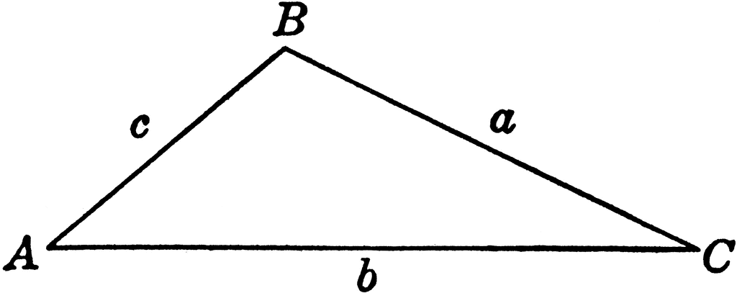

**Example**

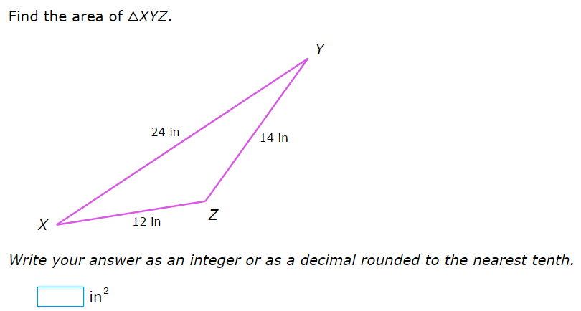

***Complete IXL Precalculus Skill M.17 Area of a triangle: Heron’s formula***